Annual State of the Corpus Christi Police Department Breakfast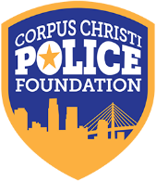
Wednesday, January 17, 2018 Solomon Ortiz Center

The Corpus Christi Police Foundation Annual Breakfast Fundraiser is a mainstay event. The Foundation engages in an effort to leverage private resources to fund high priority law enforcement needs that are beyond the scope of the City budget. As guests enjoy breakfast, they interact with members of the police force, and are entertained and educated by the Corpus Christi Police Chief’s state of address program and presentation.

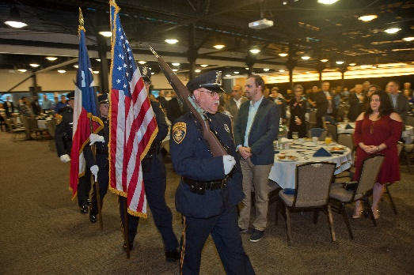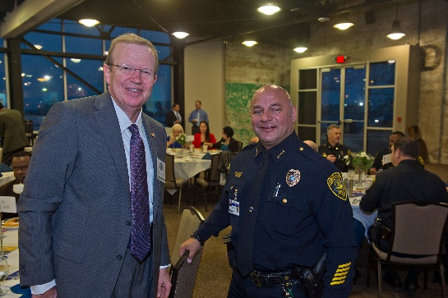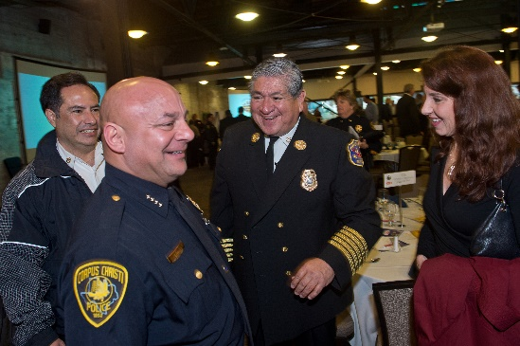

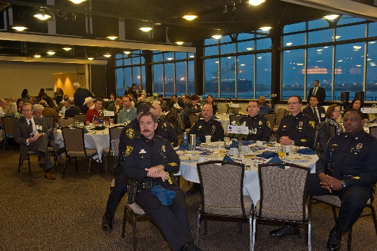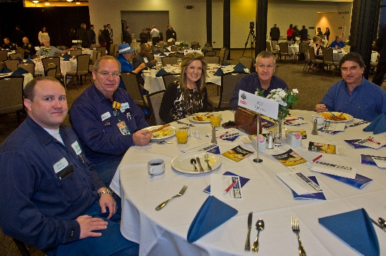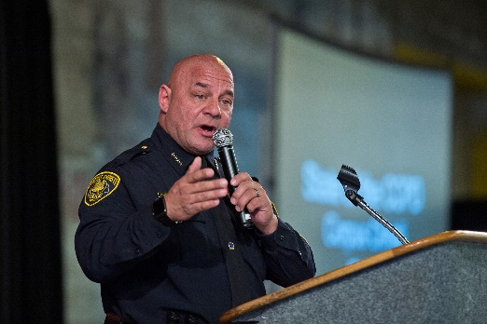

Our mission is to create a safer Corpus Christi by strengthening the bond between the CCPD and the citizens it serves. With community support, we can help foster a better equipped, better trained police force and a better informed and more engaged public.

Sponsorship Level and Incentives

- Chief Presenting Sponsor $20,000
- Plaque commemorating your contribution with logo
- Thank you ad in the Corpus Christi Caller Times acknowledging sponsorship with logo
- Visual and onstage recognition at the annual State of the CCPD Breakfast
- Premiere reserved seating for 20 (two tables of 10) by the Chief’s table
- Lunch for four with the Chief of Police and Foundation President
- Ride with a Police Officer Experience for up to six for individual ride-alongs
- Tour of Police Headquarters for six
- Recognition in breakfast program, Corpus Christi Police Foundation website and Facebook with photo

- Assistant Chief Circle: $10,000
- Thank you ad in the Corpus Christi Caller Times acknowledging sponsorship with logo
- Visual and onstage recognition at the annual State of Police Breakfast
- Premiere reserved seating for 10 (one table of 10) by the Chiefs table
- Lunch for two with the Chief of Police and Foundation President
- Ride-along for up to six individuals
- Tour of Police Headquarters for 3
- Recognition in breakfast event program, Corpus Christi Police Foundation website, and Facebook with logo

- Commander Circle: $5,000
- Thank you ad in the Corpus Christi Caller Times acknowledging sponsorship with logo
- Visual and onstage recognition at the annual State of Police Breakfast
- Premiere reserved seating for 10 (one table of 10) by the Chiefs table
- Lunch for two with the Chief of Police and Foundation President
- Ride-along for up to six individuals
- Recognition in breakfast program, Corpus Christi Police Foundation website.

- Captain Circle: $2,500
- Thank you ad in the Corpus Christi Caller Times acknowledging sponsorship by name in print
- Visual and onstage recognition at the annual State of Police Breakfast
- Reserved seating for table of 10
- Recognition in breakfast program, Corpus Christi Police Foundation website

- Lieutenant Circle $1,500
- Visual and onstage recognition at the annual State of Police Breakfast
- Reserved seating for table of 10
- Recognition in breakfast program Corpus Christi Police Foundation website

- Officer Circle: $1,000
- Reserved seating for table of 10
- Recognition in breakfast program

Corpus Christi Police Foundation Sponsorship Form

Corpus Christi Police Foundation 2018 State of Corpus Christi Police Breakfast Sponsorship Agreement
Yes! We want to sponsor the Corpus Christi Police Foundation at the following level:

- Chief Presenting Sponsor $20,000
- Assistant Chief Circle $10,000
- Commander Circle $ 5,000
- Captain Circle $ 2,500
- Lieutenant Circle $ 1,500
- Officer Circle $ 1,000
- Individual Ticket(s) ______ $ 100
- I would like to become a 100 Club Member for $100 per decal. Number of decals _____ Total $_____
- I would like to donate $_______ to help support our police department.

Payment Information
How will you be making your contribution?
- A check, payable to the Corpus Christi Police Foundation, is enclosed.
- Please send an invoice to the address below.
- Please charge my credit card:

- Visa MasterCard American Express

Card Number:

Name on Card:

Expires on: Billing ZIP Code:

Signature:
- Please send a receipt and your 501(c)(3) verification for my records.
Contact Information

Contact Name:

Company Name:

Address:

City/State/ZIP:

Email Address: Phone:

Complete and return this form to:
Cissy Garcia, Executive Director
P.O. Box 803
Corpus Christi, TX 78403
c.garcia@supportccpd.org
Thank you for your support!

